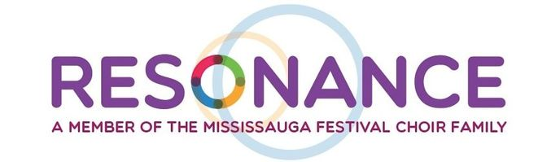
Raise Resonance Silent Auction Donation Form
Thank you for your interest in donating to the Raise Resonance Silent Auction, taking place on November 23, 2019. Please fill out the form below and email it to Alexandra Folkes at folkesalex@gmail.com to confirm your donation.
Company Name:______________________________________________________________
Donation Item:________________________________________________________________
Donation Description:___________________________________________________________
Donation Value: $________________
Do you need us to pick up the item (circle one): Yes / No
Contact Name:______________________________________________________________
Contact Number: ____________________________________________________________
How would you like to be recognized in our event program: __________________________________________________________________________
Would you be interested in attending the Raise Resonance Campaign Celebration Concert?
(circle one): Yes / No

